**Department of Electronic Engineering  
City University of Hong Kong  
EE5415 Mobile Applications Design and Development**

**Individual Project: Money Manager**

1. **Objectives**

-To build a Money Manager app

-To make sure that application can cover daily life bill recording.

**II. Introduction**

I build this application to manage my every income and expend. I use one activity to add new record. And every time when I add a new record, the application will refresh the fragment to show the newest sums of incomes and expenditures. This is application also provides lots of different selections to cover your daily life.

**III. Function Design**

**A. The main page**

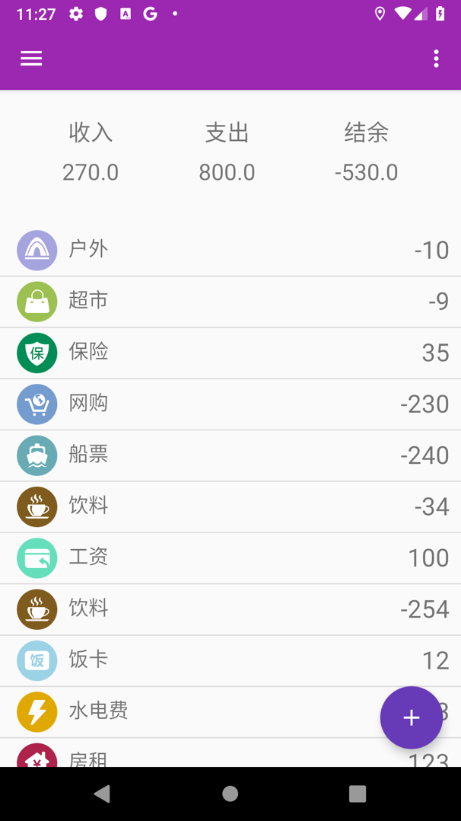

In this page, I create a main activity which contains a List View, a Drawer Layout, a floating button and the Sum fragment. The List View is used to get those records from the GreenDAO database. I also add a long press function to remove a record. We can long press a record in the List View, and it will pop up a content selection to remove this record. The Drawer Layout is also very useful, I want to get account function in it. However, I have not finished it yet. Above the List View, there is a fragment with incomes, expends, and rest. This fragment is added to activity dynamically. So when I add a record or remove a record, this fragment can refresh in time. It is very easy to know the sum of your money, how much you spent and how much you earned. At the right bottom corner, there is a floating button with a plus icon. When we push this button, we can add a new record into GreenDAO database and List View Adapter. Which means we can add records into List View dynamically.

**B. add record page**

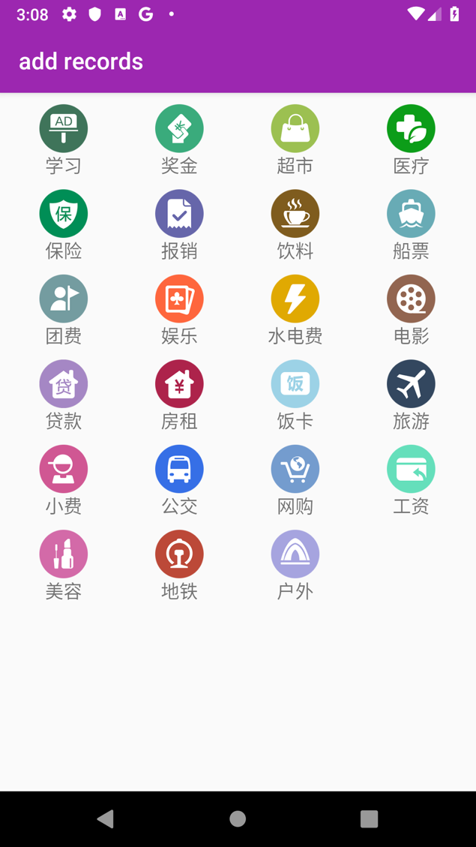

This is “add records” page. In this page we can add a new record into our database. As we can see I use a Grid View and customized Alert Dialog in this page. When we are going to add a new record in this activity, we need to push an item in the Grid View. Then a customized Alert Dialog will pop up. There are image and content which are gotten from push action, and an EditText widget. And there are two buttons in the dialog. One is income, and another one is expenditure. After press the button, it will create a new record and send it to main activity to store and show it in the view.

**IV. Software Structure**

As we can see, there are several classes and two activities in my individual project. Let me introduce this project from main activity. In main activity, it uses “MyAdapter” for List View. “MyAdapter” contains the setView method and add/remove methods to control the List View items display. Data is an entity class which use to store the records. In data, each record has id, image id, content and date. Main activity also contains the “TheSum” fragment which used to show the sum of incomes, expenditures and rests.

Then we can talk about Select Activity. When we touch floating button, Main Activity will create an intent to start Select Activity for result. Of course, the result is a data. In Select Activity, we have a Grid View to show those little items. To get those items, I create another class named Icon. Each Icon has an image and a content. We can use “ImageAdapter” to add images into Grid View. For now, I only put 23 items into the Grid View. Then I put “OnItemClickListener” into the Select Activity to get the image and content we click and use them create an Alert Dialog. Then we can use the dialog to create a new record. Then we push the button, the dialog dismisses and puts new record into an intent then send it back to Main Activity as a result.

To restore records into device, I use GreenDAO to build a database. DaoMaster has DevOpenHelper to get a writable database. DaoMaster can use the database to get a new DaoSession. Then we can use DaoSession to get a DataDao, then we can use it to control our database.

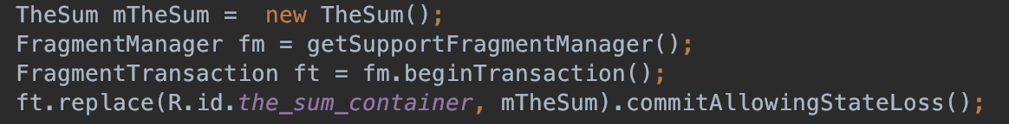

To refresh our fragment when we add a new record into database, we need to add the fragment into Main Activity dynamically. I use the code to refresh my fragment. Use FragmentManager to create a Transaction. Then use the Transaction to replace new fragment into the container and commit the transaction. Then we can get the new fragment in Main Activity.

**V. UI Design**

For UI design, the acitivity_main contains a Drawlayout. There is a **app_bar_main.xml** and Navigation layout in it.

In the **app_bar_main.xml**, there is a special AppBarLayout to store Toolbar. And it includes another **content_main.xml** which contains the Main Activity’s layout.

I use **input_window.xml** to design the Alert Dialog’s layout. And **fragment_the_sum.xml** is used to design the fragment’s layout.

**item_list.xml** and **item_grid.xml** is used to design the ListView and GridView item layout.

**content_main.xml** contains Framelayout as a container to hold the fragment’s layout. And ListView is used to hold ListView.

**VI. Implementation Detail**

In this project, I try to use those views and widgets we learned in course. I use list view and grid view to show records and selection items. Then I use GreenDAO to store the records, which is very convenient to control the database. And I use a customized Alert Dialog to send new records from Select Activity to Main Activity. Intent is used to send data from Select Activity to Main Activity. In Main Activity, I use a fragment to calculate the sum of incomes and expenditures. Then add this fragment into Main activity dynamically. We can refresh the fragment when the database is changed.

I also use git to control the version my project, this is my project’s link. You can get my project from it.

https://github.com/Glasser97/individualproject.git